231901005

Security Principles

EX-NO:02

AIM:

Learn about the security triad and common security models and principles.

PROCEDURE:

Task 1: Introduction

Task 2: CIA

Task 3: DAD

Task 4: Fundamental Concepts of Security Models

Task 5: Defence-in-Depth

Task 6: ISO/IEC 19249

Task 7: Zero Trust versus Trust but Verify

Task 8: Threat versus Risk Task 9: Conclusion

Task 1:

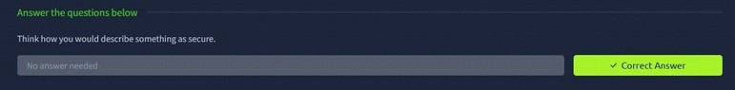

Task 2:



Task 3:

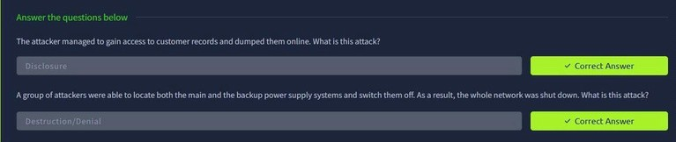

Task 4:

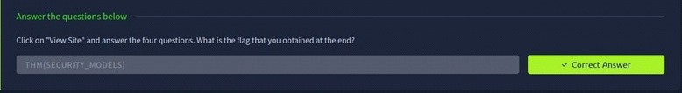

Task 5:

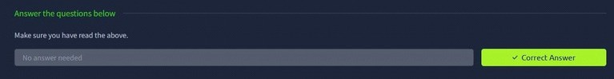

Task 6:

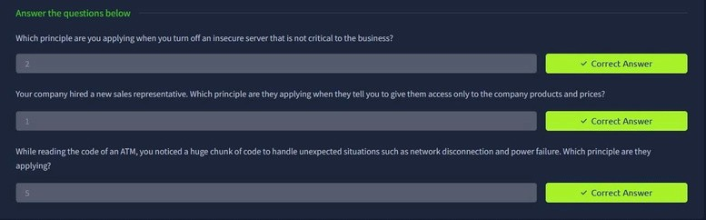

Task 7:

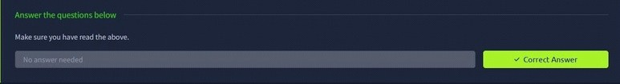

Task 8:

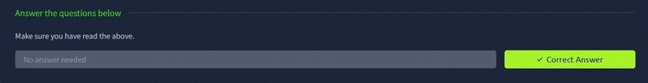

Task 9:

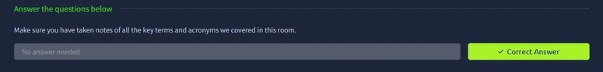

RESULT:

Thus the security principles successfully completed in tryhackme platform.